Q1. Design a web page as shown as below:

<!DOCTYPE html>

<html lang="en">

<head>

<meta charset="UTF-8">

<meta name="viewport" content="width=device-width, initial-scale=1.0">

<title>Table Formatting</title>

<link rel="stylesheet"type="text/css" href="style.css"

</head>

<body>

<center>

<table >

<caption><h1>The Mobile AMBULANCE-EMRI 108</h1></caption>

<tr>

<th>Special Equipments</th>

<th colspan="2" >Specifications/Performance</th>

</tr>

<tr>

<td>Retractable protective armour</td>

<td>Engine Type</td>

<td>Jet Turbine</td>

</tr>

<tr>

<td>Weapons System</td>

<td>Thrust</td>

<td>150fbs@<br>103%ROS</td>

</tr>

<tr>

<td>Instruments-Aircraft</td>

<td>Torque</td>

<td>175lbs@<br>98.7%ROS</td>

</tr>

<tr >

<td rowspan="10"><img src="download.jpg"></td>

<td>0-60MPH></td>

<td>3.7sec</td>

</tr>

<tr>

<td>Top Speed</td>

<td>Unknown</td>

</tr>

<tr>

<td>Break Rate</td>

<td>Excellent</td>

</tr>

<tr>

<td>Wheel Base</td>

<td>141.12in</td>

</tr>

<tr>

<td>Length</td>

<td>300.5in</td>

</tr>

<tr>

<td>Width</td>

<td>100.0in</td>

</tr>

<tr>

<td>Height</td>

<td>200.25in</td>

</tr>

<tr>

<td>Wheels </td>

<td>Cast Alloy 15X7.5</td>

</tr>

<tr>

<td>Fuel Required </td>

<td>pure petrol with 99.9% free carbon</td>

</tr>

</table>

</center>

</body>

</html>

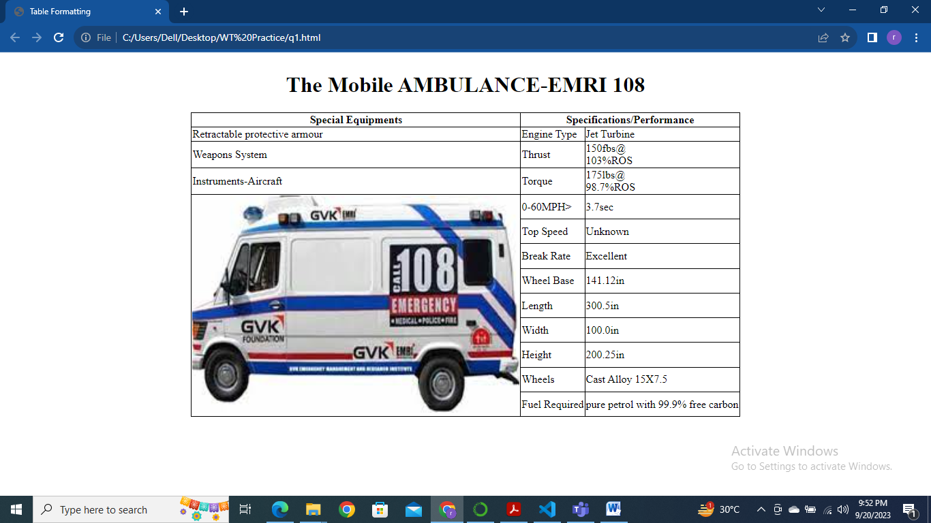

Q2. Design a web page as shown as below:

!DOCTYPE html>

<html lang="en">

<head>

<meta charset="UTF-8">

<meta name="viewport" content="width=device-width, initial-scale=1.0">

<title>Image With Text</title>

</head>

<style>

img{

width: 30%;

height: auto;

}

p{

font-size: medium;

}

footer,p{

margin-bottom: 15%;

}

</style>

<body>

<p><img src="download.jpg" alt="AMBULANCE-IMAGE"> GVK EMRI Emergency Management and Research Institute is a pioneer in Emergency Management Services in India As a not-for-profit professional organization operating in the Public Private Partnership(PPP) mode GVK EMRI is the only professional Emergency Service Provider in India today GVK EMRI handles medical, police and fire emergencies durough the "1-0-8 Emergency service" This is a free service delevered through state-of-art emergency call response centres and has over 2600 ambulances across Andhra Pradesh, Gujarat Uttarakhand, Goa, Cha Rajasthan Karnataka Assam Meghalaya and Madhya Pradesh. With the expansion of fleet and services set to spread across more states, GVK EMRI will have more than 10000 mbulances covering over a billion population by 2011</p>

<center><footer><p>Thank You For Having Intrest</p></footer></center>

</body>

</html>

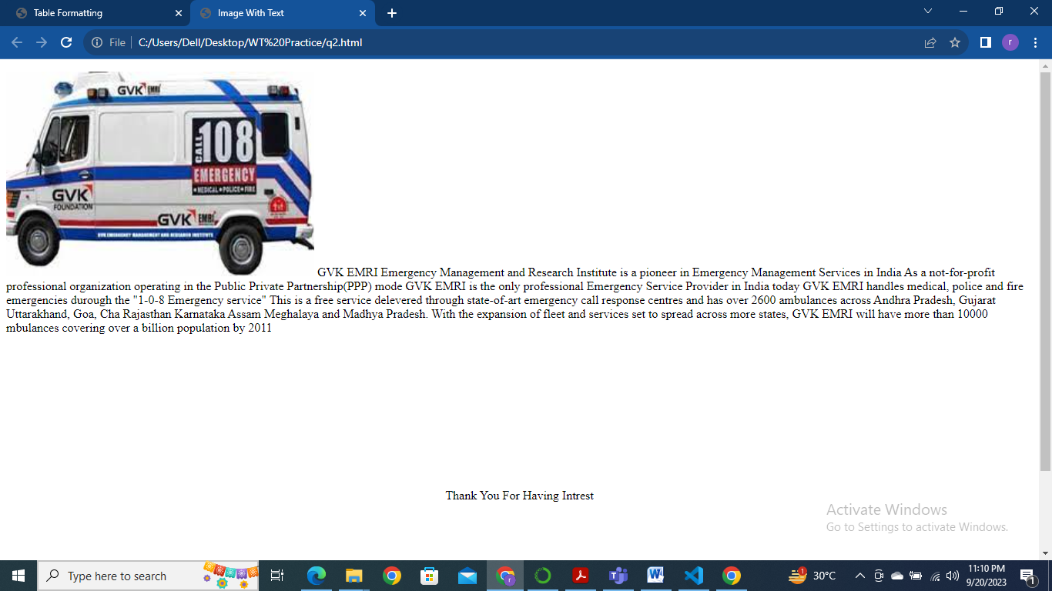

Q3. Create your own portfolio using bootstrap template like as shown as below:

<!DOCTYPE html>

<html lang="en">

<head>

    <meta charset="UTF-8">

    <meta name="viewport" content="width=device-width, initial-scale=1.0">

    <title>Your Portfolio</title>

    <!-- Add Bootstrap CSS link here -->

    <link rel="stylesheet" href="https://maxcdn.bootstrapcdn.com/bootstrap/4.5.2/css/bootstrap.min.css">

    <!-- Add your custom CSS here -->

    <link rel="stylesheet" href="styles.css">

</head>

<body>

    <!-- Navigation Bar -->

    <nav class="navbar navbar-expand-lg navbar-dark bg-dark">

        <a class="navbar-brand" href="#">RHYTHM DHINGRA</a>

        <button class="navbar-toggler" type="button" data-toggle="collapse" data-target="#navbarNav" aria-controls="navbarNav" aria-expanded="false" aria-label="Toggle navigation">

            <span class="navbar-toggler-icon"></span>

        </button>

        <div class="collapse navbar-collapse" id="navbarNav">

            <ul class="navbar-nav ml-auto">

                <li class="nav-item">

                    <a class="nav-link" href="#about">About</a>

                </li>

                <li class="nav-item">

                    <a class="nav-link" href="#portfolio">Portfolio</a>

                </li>

                <li class="nav-item">

                    <a class="nav-link" href="#contact">Contact</a>

                </li>

            </ul>

        </div>

    </nav>

    <!-- Header Section -->

    <header class="header">

        <div class="container">

            <div class="row align-items-center">

                <div class="col-lg-6">

                    <h1>RHYTHM DHINGRA</h1>

                    <p>Web Developer</p>

                    <a href="#contact" class="btn btn-primary btn-lg">Contact Me</a>

                </div>

                <div class="col-lg-6">

                    <!-- Add an image of yourself here -->

                    <img src="rhythm.jpg" alt="Your Name" class="img-fluid" height="200px" width="200px">

                </div>

            </div>

        </div>

    </header>

    <!-- About Section -->

    <section id="about" class="about">

        <div class="container">

            <div class="row">

                <div class="col-lg-6">

                    <h2>About Me</h2>

                    <p>An aspiring software developer who are specialised in C,C++,Java, PHP.I have completed Advance Course in Data Science. I am passionate about the computer with knowledge of computer languages and application.

                        I am keen to learn and explore more information and experience. I want to work for advance levels in the same.

                        I have also made project on Library Management System in PHP language in bachelors degree.

                       I have done 8 weeks training for Android App Development from Internshala Trainings in June, 2020.

                       I have the main motive of being a software developer and take deeper knowledge in development of softwares.</p>

                </div>

                <div class="col-lg-6">

                    <!-- Add any additional information or skills here -->

                    <h2>Skills</h2>

                    <ul>

                        <li>HTML/CSS</li>

                        <li>JavaScript</li>

                        <li>Bootstrap</li>

                        <li>PHP</li>

                    </ul>

                </div>

            </div>

        </div>

    </section>

    <!-- Portfolio Section -->

    <section id="portfolio" class="portfolio">

        <div class="container">

            <h2>Portfolio</h2>

            <!-- Add your portfolio projects here -->

            <div class="row">

                <div class="col-md-4">

                    <div class="card">

                        <!-- Add an image and description for each project -->

                        <img src="LMS.png" class="card-img-top" alt="Project 1">

                        <div class="card-body">

                            <h5 class="card-title">Library Management System</h5>

                            <p class="card-text">An integrated library management system (LMS) is ERP software that helps in simplifying the daily operations of the library. The purpose of a library management system is to manage & track the daily work of the library such as issuing books, return books, due calculations, etc.</p>

                        </div>

                    </div>

                </div>

                <!-- Add more projects as needed -->

            </div>

        </div>

    </section>

    <!-- Contact Section -->

    <section id="contact" class="contact">

        <div class="container">

            <h2>Contact Me</h2>

            <div class="row">

                <div class="col-md-6">

                    <!-- Add a contact form here or provide contact information -->

                    <form>

                        <div class="form-group">

                            <label for="name">Name</label>

                            <input type="text" class="form-control" id="name" placeholder="Your Name">

                        </div>

                        <div class="form-group">

                            <label for="email">Email</label>

                            <input type="email" class="form-control" id="email" placeholder="Your Email">

                        </div>

                        <div class="form-group">

                            <label for="message">Message</label>

                            <textarea class="form-control" id="message" rows="5" placeholder="Your Message"></textarea>

                        </div>

                        <button type="submit" class="btn btn-primary">Send Message</button>

                    </form>

                </div>

                <div class="col-md-6">

                    <!-- Add your contact information here -->

                    <h3>Contact Information</h3>

                    <p>Email: rhythm2411@gmail.com</p>

                    <p>Phone: +918447272757</p>

                    <p>Location: Ghaziabad, India</p>

                </div>

            </div>

        </div>

    </section>

    <!-- Add Bootstrap and custom JavaScript links here if needed -->

    <!-- Add Bootstrap JS scripts here -->

    <script src="https://maxcdn.bootstrapcdn.com/bootstrap/4.5.2/js/bootstrap.min.js"></script>

</body>

</html>

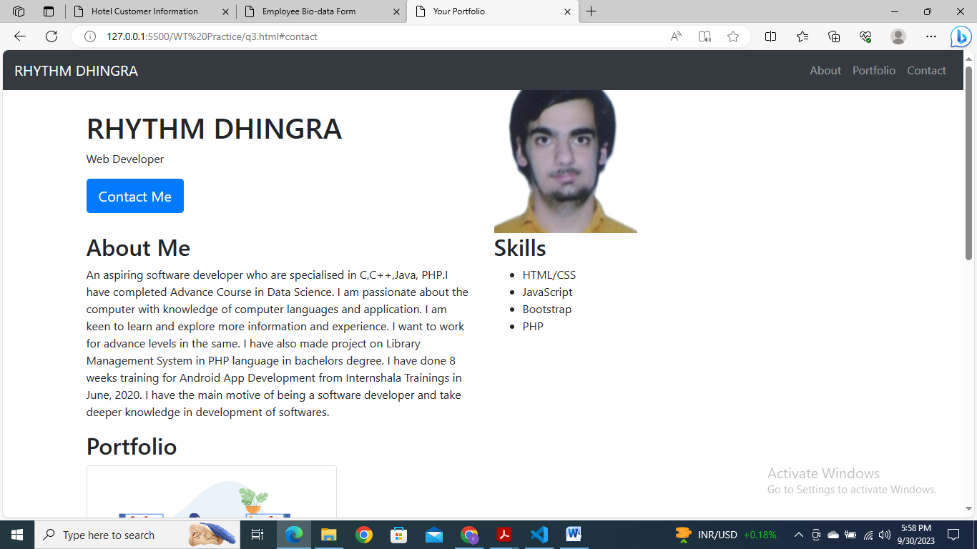

Q4. Design a web page for data entry of customer’s in a Hotel. The customer information should include Name, Address, Age, gender, Room Type (A/C, Non- A/C or Deluxe), Type of payment (Cash, Credit/Debit Card or Coupons) with validation by using JavaScript

<!DOCTYPE html>

<html lang="en">

<head>

    <meta charset="UTF-8">

    <meta name="viewport" content="width=device-width, initial-scale=1.0">

    <title>Hotel Customer Information</title>

    <style>

        body {

            font-family: Arial, sans-serif;

        }

        .container {

            max-width: 600px;

            margin: 0 auto;

            padding: 20px;

            border: 1px solid #ccc;

            border-radius: 5px;

            box-shadow: 0 0 10px rgba(0, 0, 0, 0.1);

        }

        label {

            display: block;

            margin-bottom: 5px;

        }

        input[type="text"],

        input[type="number"],

        select {

            width: 100%;

            padding: 10px;

            margin-bottom: 15px;

            border: 1px solid #ccc;

            border-radius: 3px;

        }

        button[type="submit"] {

            background-color: #007BFF;

            color: #fff;

            padding: 10px 20px;

            border: none;

            border-radius: 3px;

            cursor: pointer;

        }

        button[type="submit"]:hover {

            background-color: #0056b3;

        }

    </style>

</head>

<body>

    <div class="container">

        <h1>Customer Information</h1>

        <form id="customerForm" onsubmit="return validateForm()">

            <label for="name">Name:</label>

            <input type="text" id="name" name="name" required>

            <label for="address">Address:</label>

            <input type="text" id="address" name="address" required>

            <label for="age">Age:</label>

            <input type="number" id="age" name="age" required>

            <label for="gender">Gender:</label>

            <select id="gender" name="gender" required>

                <option value="male">Male</option>

                <option value="female">Female</option>

                <option value="other">Other</option>

            </select>

            <label for="roomType">Room Type:</label>

            <select id="roomType" name="roomType" required>

                <option value="ac">A/C</option>

                <option value="nonAc">Non-A/C</option>

                <option value="deluxe">Deluxe</option>

            </select>

            <label for="paymentType">Payment Type:</label>

            <select id="paymentType" name="paymentType" required>

                <option value="cash">Cash</option>

                <option value="card">Credit/Debit Card</option>

                <option value="coupons">Coupons</option>

            </select>

            <button type="submit">Submit</button>

        </form>

    </div>

    <script>

        function validateForm() {

            // Validation logic can be added here

            // For example, you can check if the age is a positive number, etc.

            return true; // Return true to submit the form; false to prevent submission

        }

    </script>

</body>

</html>

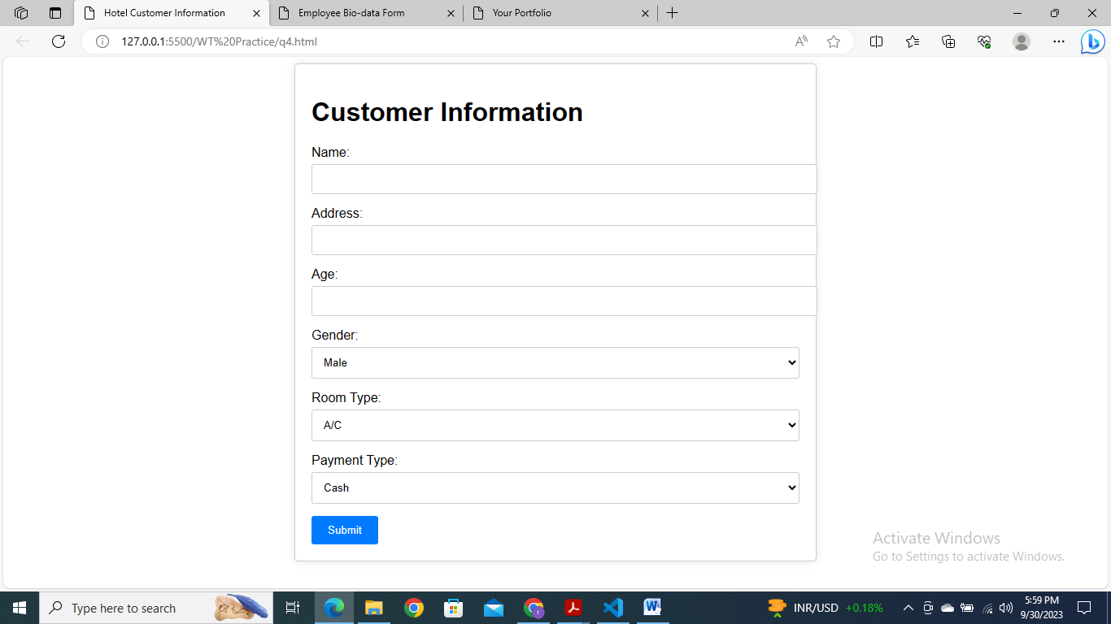

Q5. Design a web page to take bio-data information of current employees in any organization with validation using JavaScript.

<!DOCTYPE html>

<html lang="en">

<head>

    <meta charset="UTF-8">

    <meta name="viewport" content="width=device-width, initial-scale=1.0">

    <title>Employee Bio-data Form</title>

    <style>

        body {

            font-family: Arial, sans-serif;

        }

        .container {

            max-width: 600px;

            margin: 0 auto;

            padding: 20px;

            border: 1px solid #ccc;

            border-radius: 5px;

            box-shadow: 0 0 10px rgba(0, 0, 0, 0.1);

        }

        label {

            display: block;

            margin-bottom: 5px;

        }

        input[type="text"],

        input[type="number"],

        select {

            width: 100%;

            padding: 10px;

            margin-bottom: 15px;

            border: 1px solid #ccc;

            border-radius: 3px;

        }

        button[type="submit"] {

            background-color: #007BFF;

            color: #fff;

            padding: 10px 20px;

            border: none;

            border-radius: 3px;

            cursor: pointer;

        }

        button[type="submit"]:hover {

            background-color: #0056b3;

        }

    </style>

</head>

<body>

    <div class="container">

        <h1>Employee Bio-data Form</h1>

        <form id="employeeForm" onsubmit="return validateForm()">

            <label for="fullName">Full Name:</label>

            <input type="text" id="fullName" name="fullName" required>

            <label for="employeeID">Employee ID:</label>

            <input type="text" id="employeeID" name="employeeID" required>

            <label for="email">Email:</label>

            <input type="email" id="email" name="email" required>

            <label for="phoneNumber">Phone Number:</label>

            <input type="tel" id="phoneNumber" name="phoneNumber" pattern="[0-9]{10}" required>

            <small>Enter a 10-digit phone number.</small>

            <label for="department">Department:</label>

            <input type="text" id="department" name="department" required>

            <label for="salary">Salary:</label>

            <input type="number" id="salary" name="salary" required>

            <button type="submit">Submit</button>

        </form>

    </div>

    <script>

        function validateForm() {

            // Basic validation: You can add more specific validation rules here.

            const phoneNumberRegex = /^[0-9]{10}$/;

            const fullName = document.getElementById("fullName").value;

            const employeeID = document.getElementById("employeeID").value;

            const email = document.getElementById("email").value;

            const phoneNumber = document.getElementById("phoneNumber").value;

            const department = document.getElementById("department").value;

            const salary = document.getElementById("salary").value;

            if (fullName.trim() === "" || employeeID.trim() === "" || email.trim() === "" || phoneNumber.trim() === "" || department.trim() === "" || salary.trim() === "") {

                alert("All fields are required.");

                return false;

            }

            if (!phoneNumber.match(phoneNumberRegex)) {

                alert("Please enter a valid 10-digit phone number.");

                return false;

            }

            return true; // Return true to submit the form; false to prevent submission

        }

    </script>

</body>

</html>

